DIS-AM,C-Taino-Cemi-Type 1-Skeletal Mask

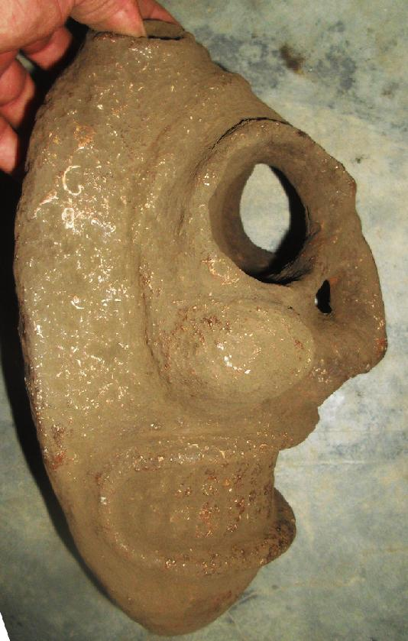

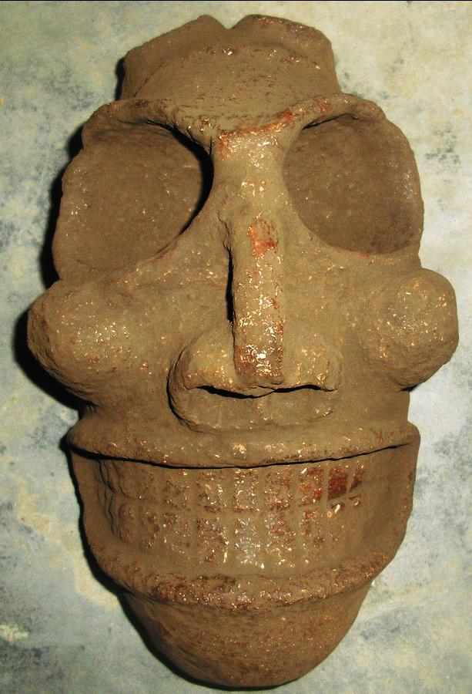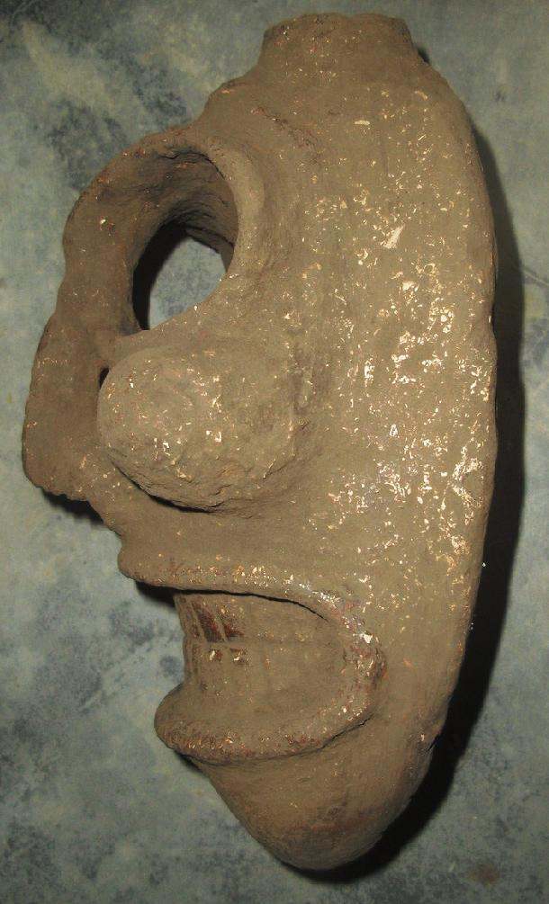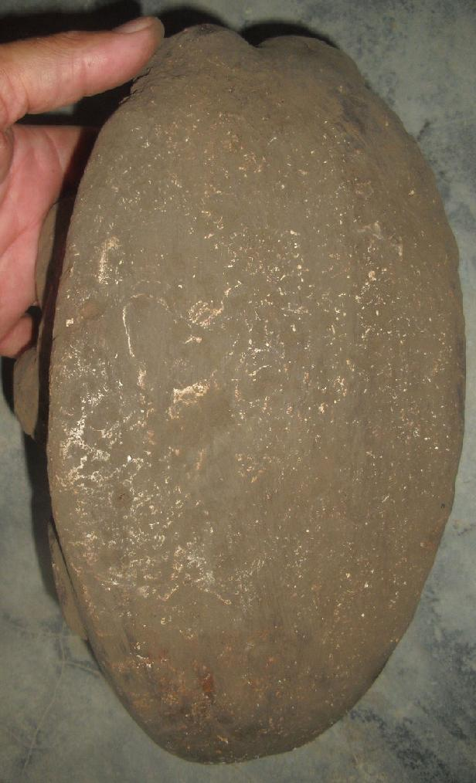

### Delivery package 1 of 1

Estimated delivery Friday, Apr 29, 2016 - Wednesday, May 18, 2016

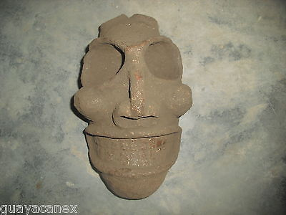

#### [Taino head of stone](http://www.ebay.com/itm/331798108152)

|  |  |
| --- | --- |
| Item price | $399.00 |
| Quantity | 1 |
| Item number | 331798108152 |
| Shipping service | Economy Shipping |

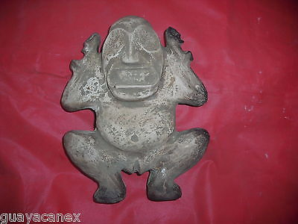

#### [Taino Zemi of stone/mother earth in excellent condition](http://www.ebay.com/itm/331798113138)

|  |  |
| --- | --- |
| Item price | $199.00 |
| Quantity | 1 |
| Item number | 331798113138 |
| Shipping service | Economy Shipping |

## Shipping address

Ralph J Coffman Jr

149 Atlantic Ave

Swampscott MA 01907-2427

United States

## Order total

|  |  |
| --- | --- |
| Subtotal | $598.00 |
| Shipping | Free |

**Total**

$598.00

Order placed on

Wednesday, Mar 16, 2016

Payment method

PayPal

Payment date

Wednesday, Mar 16, 2016